Progress Report 7

Last week the goal was to create an enjoyable user experience and a brief use case diagram was built. This week it is expanded and includes descriptions along with a class diagram.

1. Use Case Diagram

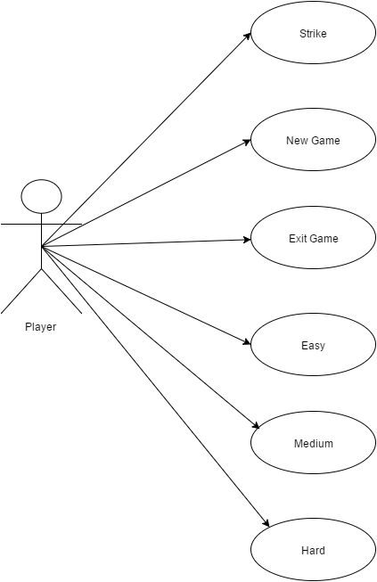

1. Use Case Descriptions

Use Case Name: Strike

Actors: Player

Description: This use case lets the player select a row and target to attack.

Preconditions:

1. Row and column field have input

Postconditions:

1. Row and column inputted will be attacked

Basic Flow of Events:

1. Player enters row to attack
2. Player enters column to attack
3. Player selects “Strike!” button
4. Map is changed

Alternative Flow:

1a. Player doesn’t enter row

Game will not attack

1b. Player enters invalid row

Game will not attack

2a. Player doesn’t enter column

Game will not attack

2b. Player enters invalid column

Game will not attack

Use Case Name: New Game

Actors: Player

Description: This use case lets the player refresh the map on screen and resets all counters.

Preconditions:

1. Game is already in session

Postconditions:

1. Game will reset

Basic Flow of Events:

1. Player selects “New Game” from start menu
2. Game resets map

Alternative Flow:

2a. If game is on a level

Game will reset requirements for that level.

Use Case Name: Exit

Actors: Player

Description: This use case lets the player exit the game.

Preconditions:

1. Game is already in session

Postconditions:

1. Game will exit

Basic Flow of Events:

1. Player selects “Exit”
2. System exits

Alternative Flow:

None

Use Case Name: Easy

Actors: Player

Description: This use case lets the player choose an easy difficulty.

Preconditions:

1. Game is already in session

Postconditions:

1. Game will launch easy difficulty

Basic Flow of Events:

1. Player selects “Easy” from the difficulty menu.
2. Game will set requirements for that level.

Alternative Flow:

2a. Player is on different difficulty

Game will change requirements to new ones for the level chosen.

Use Case Name: Medium

Actors: Player

Description: This use case lets the player choose medium difficulty.

Preconditions:

1. Game is already in session

Postconditions:

1. Game will launch medium difficulty

Basic Flow of Events:

1. Player selects “Medium” from the difficulty menu.
2. Game will set requirements for that level.

Alternative Flow:

2a. Player is on different difficulty

Game will change requirements to new ones for the level chosen.

Use Case Name: Hard

Actors: Player

Description: This use case lets the player choose hard difficulty.

Preconditions:

1. Game is already in session

Postconditions:

1. Game will launch hard difficulty

Basic Flow of Events:

1. Player selects “Hard” from the difficulty menu.

1. Game will set requirements for that level.

Alternative Flow:

2a. Player is on different difficulty

Game will change requirements to new ones for the level chosen.

1. Class Diagram

